ONGOING PROJECT REPORT SUBMITTED BT DR. PRADIP KUMAR DAS , FOUNDER SECRETARY OF SWASTHYA BHABNA WELFARE SOCIETY AS A PART OF FUND OBTAINED FROM GALDERMA SKINPACT AWARD 2017.

Title-Water treatment to mitigate arsenic pollution in different arsenic affected villages of West Bengal
Lead Dermatologist: Dr. Pradip Kumar Das, MBBS, DTM&H, Ph.D, D.Lit.MBA
Project team members: Dr. Suhas Bhattacharya,M.SC, Ph.D, Dr. Sourav Dhara,MBBS, DVD, Dr. Kathakali Chatterjee, MBBS, M.D. Affiliation: Swasthya Bhabna Welfare Society, India.

Executive summary
This project aims to provide arsenic-free ‘safe’ drinking water to the villagers under seven districts of Paschimbanga in West Bengal; and purposeful mitigation of arsenicosis through community action and creating mass awareness. Great attention is aimed for the rural communities for their empowerment to prevent and reduce arsenic contamination in groundwater using low cost, low maintenance, and sustainable solutions. Relief from skin disease for the affected victims are also aimed for the prevention of further complications of arsenicosis. Overall sustained environmental development and better quality of life are looked for by uplifting their socio-economical development.

Project beneficiaries:
Target groups represent the population which is already affected or at risk of arsenic contamination, with a focus on the basic needs of the people in arsenic affected villages under seven districts of Paschimbanga (North 24Prgs., South 24Prgs., Malda, Murshidabad, Nadia, Burdwan and Hooghly). 2 arsenic affected villages of Nadia district have already been covered, the details are mentioned in the tabular form.
NAME OF DISTRICT- NADIA NAME OF BLOCK- HARINGHATA
Table-I Tabular picture of Arsenic affected villages
Name of village | No. of Family members surveyed | Male Members | Female members | Child members | No. of Arsenic patients
Nonaghata-Uttarpara | 213 | 86 | 112 | 15 | 07
Nonaghata- Majherpara | 198 | 91 | 93 | 14 | 04
Total- 2 villages | 411 | 177 | 205 | 29 | 11
Table I shows on behalf of Swasthya Bhabna Welfare Society, its workers at the onset started house to house survey of 2 Arsenic affected villages named as Nonaghata Uttarpara and Nonaghata Majherhat selected for survey works as these two villages under Haringhata Block of Nadia District were mentioned as Arsenic affected villages by PHE ( Public Health Engineering Department of Government of West Bengal, after 7 days survey works by the workers of Swasthya Bhabna Welfare Society, revelaled that out of 411 members surveyed of which 213 members belonged to Nonaghata-Uttarpara and 198 belonged to Nonaghata –Majherhat village, total male members were 177 and female members were 205 and child members were 29. In the medical camps organized by Society, Dermatologists detected 11 Arsenic patients of which 7 patients coming from Nonaghata Uttarpara and 4 patients from Nonaghata – Majherpara.
Table-II Tabular picture of Arsenicosis patients
Total No. of Arsenicosis patients | No. of skin infections other than Arsenic/ Non Arsenic patients | No. of normal  Persons not affected by any diseases | Name of the affected village |  | Total No. Members surveyed
 |  |  | Nonaghata-Uttarpara | Nonaghata-Majherhat
11 | 150 | 56 | 07 | - | 213
11 | 154 | 40 | - | 04 | 198
Table-II shows that during the organization of health check up camps in Nonaghata-Uttarpara and Nonaghata- Majherhat villages, it has been found that total 11 arsencosis patients of which 7 from Uttarpara and 4 from Majherhat village were detected, whereas other non arsenic skin infected patients were 150 and 154 respectively and all were provided with proper medicines and treatment.
Total No. of Arsenicosis patients | No. of skin infections other than Arsenic/ Non Arsenic patients | No. of normal | Name of the affected village |  | Total No. Members surveyed
 |  | Persons not affected by any diseases
 |  |  | Nonaghata-Uttarpara | Nonaghata-Majherhat
11 | 150 | 56 | 7 | - | 213
11 | 154 | 40 | - | 4 | 198
Fig.-1
Table-III Profile picture of Arsenicosis Patients
Sl.No | Sex | Age  In years | Wt.  In Kg. | Ht. in Cm | Hbin gm/100ml. | PEFR  in ml. | Gradation  Of Arsenicosis | Atypical clinical presentation
1 | F | 55 | 45 | 135 | 9.6 | 50 | II | Pitting Edema
2 | F | 17 | 43 | 150 | 9.7 | 230 | II
3 | M | 47 | 41 | 162 | 9.4 | 200 | II
4 | M | 42 | 60 | 160 | 9.4 | 190 | IV | Pit.Edema,Low BP, Ulceration
5 | F | 55 | 50 | 143 | 9.3 | 130 | II | Low BP
6 | M | 50 | 49 | 159 | 9.5 | 120 | III | Myopathy, Neuropathy
7 | M | 40 | 48 | 161 | 9.6 | 140 | II | Conjuctival congestion.
8 | M | 70 | 55 | 176 | 10.6 | 150 | III | Conjuctival congestion,ulceration,High BP, buccal pigmentation
9 | F | 42 | 45 | 148 | 10.5 | 150 | II | Buccal pigmentation
10 | F | 55 | 46 | 145 | 10.9 | 160 | II | Hypertension
11 | M | 43 | 55 | 151 | 9.0 | 160 | II | -
Table-III shows out of 11 sufferers of arsenicosis all were suffering from moderate anaemia, 2-3 suffered from hypertension, hypotension, having low to moderate peek flow rate and 1-2 patients have ulceration and pre-malignant condition
Table-IV Categorisation of Arsenicosis Patients according to their Anthropometric and Clinical gradation
Sl.No | Sex |  | Age in years |  | Wt in Kg |  | Ht. in Cm |  | Hb. In Gm% |  | PEFR in ml |  |  | Important clinical Gradation |  |  |  | Important clinical presentation
 | M | F | 13-40 | 41-70 | 40-50 | 51-60 | 130-150 | 151-180 | 8-10 | 10+ to 12 | 50-100 | 101-150 | Above 151 | I | II | III | IV | Pig.  & Edema | Low  BP | High BP | Nuuro  &  ulcer
11 | 6 | 5 | 2 | 9 | 8 | 3 | 5 | 6 | 8 | 3 | 1 | 5 | 5 | 0 | 8 | 2 | 1 | 3 | 2 | 2 | 4
Table-IV shows that out of 11 Arsenicosis patients detected in two villages, 6 were male and 6 were female, lowest age was 13 years and highest age was 70 years, most of them suffered from moderate to severe anaemia. According to severity of symptoms and signs they were divided into Grade I to Grade IV of which Grade II sufferers were 8, Grade III- were 2 and only 1 case of Grade IV was detected and he was received carcinomic treatment.
Summary of Activities and Project Outcome:-
- Established selfsustaining ‘community group’ in the project village. These community groups become actively involved in preventing and reducing arsenicosis.
- Reliable and scientifically accepted database on arsenic levels in groundwater for the project village becomes available.
- Manpower trained to carry out water quality analysis.
- Capacity building of local NGO, Voluntary Organisations and Panchayats to tackle similar problem in the locality in the future.
- A better interagency coordinated working atmosphere established for undertaking similar projects in the future.
- Better health status assured for the arsenic affected villagers.
- Rainwater harvesting structures created but cannot be implanted due to ensuing General Loksabha Election. All sectors were very busy in ensuing election. Soon after completion of Election, Project works will be started.
- .Development of effective and qualitative IEC materials for creating mass awareness (such as posters, hand bills, booklets, visual display) were prepared and circulated.
- Awareness camps organized and awareness generated in project villages.
- Medical treatment camps organized and medicines were given to the affected patients free of cost.
- Overall sustained environmental development and better quality of life assured in the arsenic affected areas by socioeconomic upliftment of the people (health expense savings diverted to productive activities).
As Project Fund through Skinpact Award 2017 was received after many turmoil, almost 10 months later from the beginning of the year we are late starter to apply our strength into the project works. However, we are trying our best to accelerate the works but imposing the General Election norms throughout the country, again we faced lot of troubles to quicken our project works in the arsenic affected villages. In spite of that difficulties prevailed into our project works , we are now trying our best to accelerate our project works. Now the present situation is such that we are unable to start our works into arsenic the affected villages. The whole process are now in temporary suspension due to ensuing General Lok Sabha Election. However, the project works performed by us so far, are given as interim report for your kind perusal.
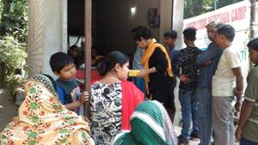
ARSENICOSIS DETECTION MEDICAL CAMP

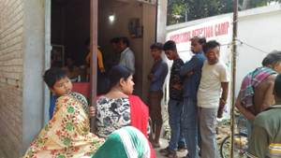
ARSENICOSIS DETECTION MEDICAL CAMP

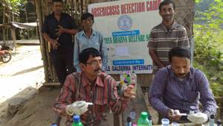
WATER TESTING CAMP FOR ARSENIC DETECTION
ARSENICOSIS DETECTION MEDICAL CAMP

ARSENICOSIS DETECTION MEDICAL CAMP

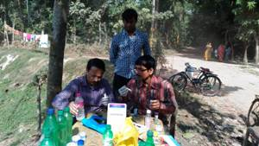
TESTING FOR ARSENIC IN DRINKING WATER
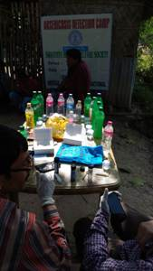
TESTING FOR ARSENIC IN DRINKING WATER

TESTING FOR ARSENIC IN DRINKING WATER
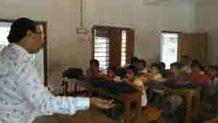
ARSENIC AWARENESS CAMPS IN SCHOOLS
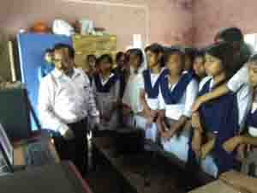
ARSENIC AWARENESS CAMPS IN SCHOOLS

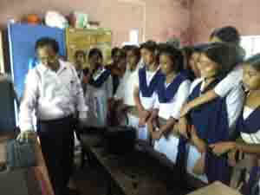
ARSENIC AWARENESS CAMPS IN SCHOOLS

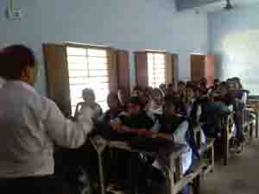
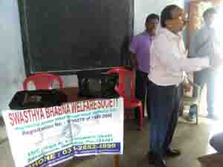
ARSENIC AWARENESS CAMPS IN SCHOOLS

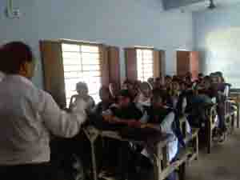
ARSENIC AWARENESS CAMPS IN SCHOOLS

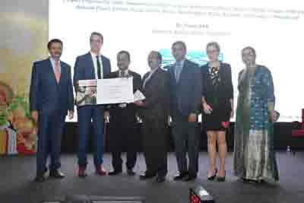
SINPACT AWARD 2017
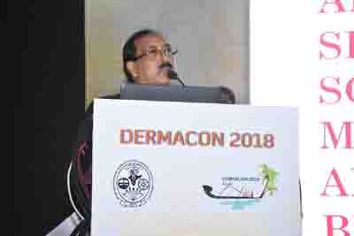
DELIVERATION OF SPEECH ON SKINPACT AWARD 2017
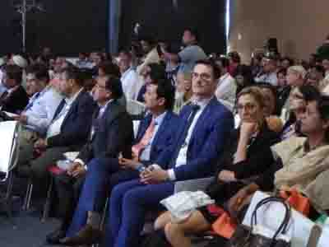
GATHERINGS IN SKINPACT AWARD CEREMONY
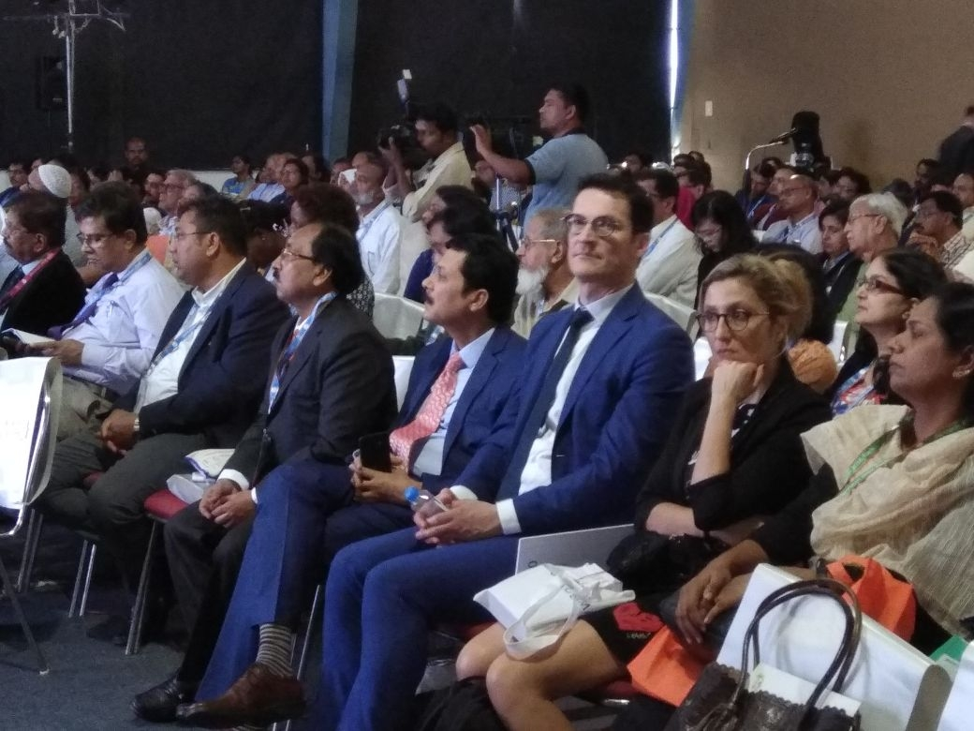
GATHERINGS IN SKINPACT AWARD CEREMONY AT KOCHI OF KERALA

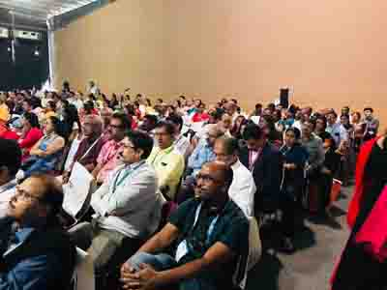
GATHERINGS IN SKINPACT AWARD CEREMONY AT KOCHI OF KERALA

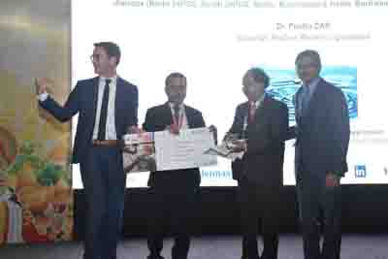
SKINPACT AWARD2017 GIVEN AT KOCHI OF KEARA STATE
